

***INSTITUTE OF INFORMATION TECHNOLOGY***

***JAHANGIRNAGAR UNIVERSITY***

**Lab Report :** 01

**Submission Date :** 18/11/2020

**Course Tittle :** Numerical Analysis Lab

**Course Code :** ICT - 2106

**Submitted To Submitted By**

[Dr M Shamim Kaiser](https://juniv.edu/teachers/rhemel) MD. Shakil Hossain

Professor Roll – 2023

IIT – JU 2nd year 1st Semester

IIT - JU

**Exercise 1.** Find the value of y = ln(sinh(exp(54 / 6* ))).

**Answer:**

>>a = 54^3

a =

157464

>> b = 6*pi

b =

18.8496

>> y = log(sinh(exp(a/b)))

y =

Inf

**Exercise 2:** Find the size, and length of following matrices

A=[1 2 3; 4 5 6;7 6 54; 65 23 45]

B=7:1:13.5

**Answer:**

>> A = [1 2 3; 4 5 6; 7 6 54; 65 23 45]

A =

1 2 3

4 5 6

7 6 54

65 23 45

>> X = size(A)

X =

4 3

>> max(size(A))

ans =

4

>> B = 7:1:13.5

B =

Columns 1 through 6

7 8 9 10 11 12

Column 7

13

>> X = size(B)

X =

1 7

>> max(size(B))

ans =

7

>>

**Exercise 3.** A=[2 3; 4 5]; B=[3 4; 6 7];

Find A+B, A*B, A.*B,A/B,A\B, A.^2,A./B

**Answer:**

>> A = [2 3; 4 5]

A =

2 3

4 5

>> B = [3 4; 6 7]

B =

3 4

6 7

>> A+B

ans =

5 7

10 12

>> A*B

ans =

24 29

42 51

>> A.*B

ans =

6 12

24 35

>> A/B

ans =

1.3333 -0.3333

0.6667 0.3333

>> A\B

ans =

1.5000 0.5000

0 1.0000

>> A.^2

ans =

4 9

16 25

>> A./B

ans =

0.6667 0.7500

0.6667 0.7143

**Exercise 4.** Plot the following functions in the same window y1=sin x, y2=sin 2x, y3=sin 3x, y4=sin 4x where x varies from 0 to pi.

**Answer:**

>> x = 0:0.1:pi;

>> y1 = sin(x);

>> y2 = sin(2*x);

>> y3 = sin(3*x);

>> y4 = sin(4*x);

>> plot(x,y1,x,y2,x,y3,x,y4)

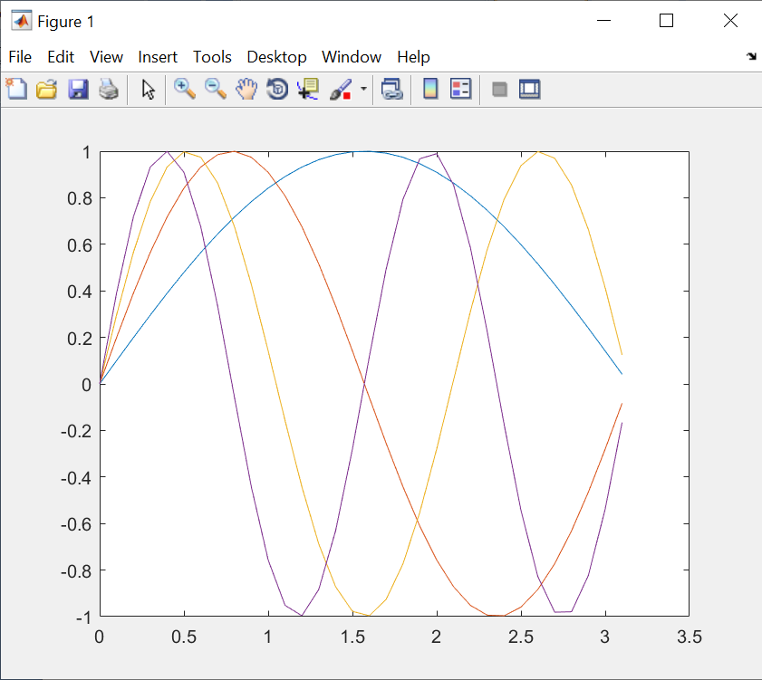

**Exercise 6.** Define the matrices

A=[17 2 3 4; 5 6 7 8; 9 10 11 12; 13 14 15 16]

B=[ 2 3 4 5 ; 6 7 8 9 ; 10 11 12 13 ; 14 15 16 17 ]

C=[ 1 2 3 ; 4 5 6 ; 7 8 9 ]

y=[ 4 3 2 1 ]'

a) Compute AB and BA. Is matrix multiplication commutative?

b) Compute AC. Why do you get an error message?

c) Solve the following system of equations:

17x1+2x2+3x3+4x4 = 4

5x1+6x2+7x3+8x4 = 3

9x1+10x2+11x3+12x4 = 2

13x1+14x2+15x3+16x4 = 1

**Answer:**

**(a)**

>> A = [17 2 3 4; 5 6 7 8; 9 10 11 12; 13 14 15 16]

A =

17 2 3 4

5 6 7 8

9 10 11 12

13 14 15 16

>> B = [2 3 4 5; 6 7 8 9; 10 11 12 13; 14 15 16 17]

B =

2 3 4 5

6 7 8 9

10 11 12 13

14 15 16 17

>> A*B

ans =

132 158 184 210

228 254 280 306

356 398 440 482

484 542 600 658

>> B*A

ans =

150 132 146 160

326 260 290 320

502 388 434 480

678 516 578 640

Yes matrix multiplication is commutative.

**(B)**

>> A=[17 2 3 4; 5 6 7 8; 9 10 11 12;13 14 15 16]

A =

17 2 3 4

5 6 7 8

9 10 11 12

13 14 15 16

>> C=[1 2 3; 4 5 6; 7 8 9]

C =1 2 3

4 5 6

7 8 9

>> A*C

Error using *

Inner matrix dimensions must agree.

**(C)**

>> A=[17 2 3 4; 5 6 7 8; 9 10 11 12;13 14 15 16]

A =

17 2 3 4

5 6 7 8

9 10 11 12

13 14 15 16

>> Y = [ 4 3 2 1 ]'

Y =

4

3

2

1

>> X=linsolve(A,Y)

Warning: Matrix is close to singular or badly scaled. Results may be inaccurate.

RCOND = 1.940034e-18.

X =

0.0000

4.7347

-14.4693

9.4847